Phase 2: Protocol Design
The research lead analyzed formal specification languages like Estelle, LOTOS, SDL, ASN.1, and Protocol Buffers, and our approach directly builds on that work. As lightweight and practical frameworks for specifying new protocols, the result suggested ASN.1 and Protocol Buffers. This foundation has been used to expand the suggested header fields into an actual packet structure with message flows, fixed field sizes, and defined semantics. This guarantees that the design is robust for Scapy implementation and Wireshark analysis, yet not too complicated to understand in instructional laboratories.

Packet Header Layout
With an optional checksum for error detection, the protocol employs a variable-length payload after a small 8-byte header.

Field | Size | Type | Description
Version | 1 B | Uint8 | Identifying the protocol version
Type | 1 B | Uint8 | Defining the message  ( 0=Request, 1=Ack, 2=Response, 3=Error )
Seq | 2 B | Uint16 | Sequence number for retransmission and sorting.
Length | 2 B | Uint16 | Length of payload in bytes
CRC16 | 2 B | Uint16 | Optional 16-bit checksum across header and payload.

Rationale:
- 1 byte each is sufficient because Version and Type are small values.
- 2 bytes (0-65,535) are standard since length and sequence can increase.
- Conventionally, CRC16 is two bytes, widely accepted, and easy to validate.

Packet Layout Diagram
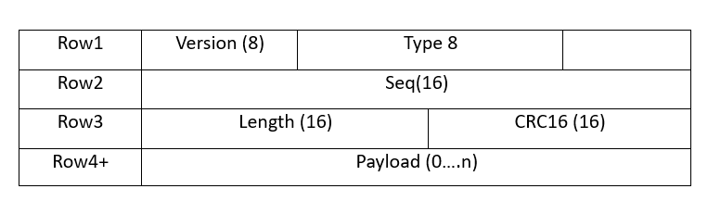

Figure1: custom protocol packet layout

Message Types
- Request (0) - client sent a request to transmit a command or data.
- Ack (1) – confirms that a request was received and echoes the Sequence value.
- Response (2) – an optional data confirmation response from the server.
- Error (3) – this indicates a sequence, CRC mismatch, or a corrupted transmission.

Protocol Behavior
It is easy to observe retransmissions in Wireshark since the protocol uses an easy stop-and-wait ARQ flow.

Custom Protocol State Machine
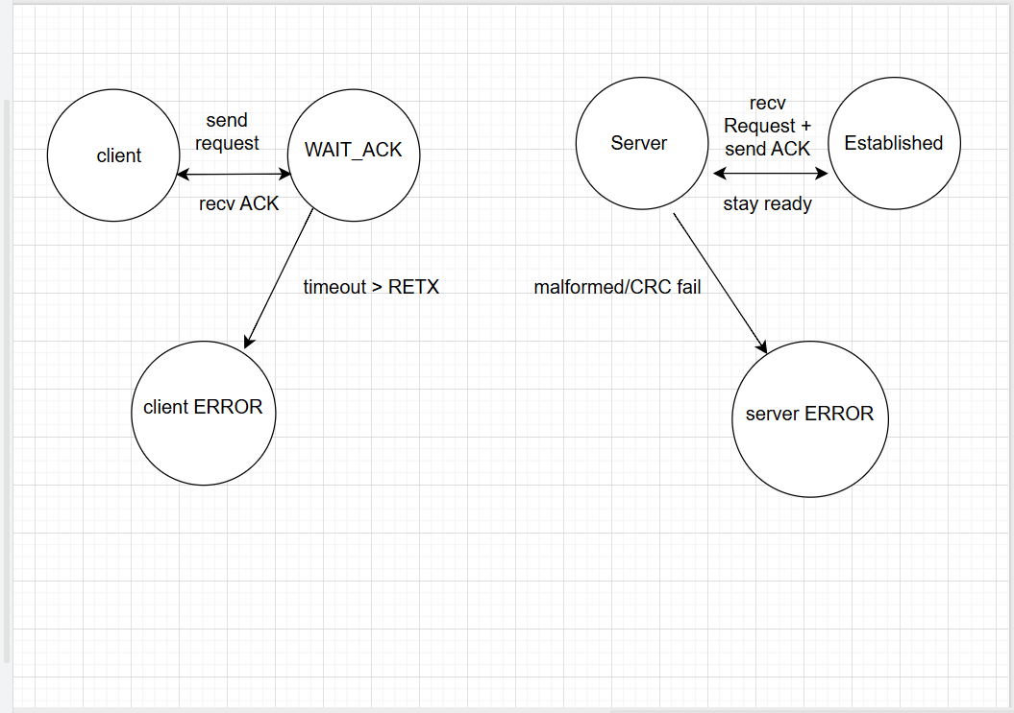

Figure2: Client-server state machines showing request/ack cycle with retransmission

Use –Case Scenarios
Chat Example
- Clients sent Request (“Hello”, Seq=1).
- Server replied with Ack(1) and optional Response(“Hi !”).
- If not Ack arrives, the client retransmits.

IoT Sensor Example
- Sensor sent Request(“temp=23.5”, Seq=n) in every 5 seconds.
- Gateway replied with Ack(n).
- If a packet is corrupted, the gateway responds with ERROR.
Message Flow Diagrams

Normal Flow
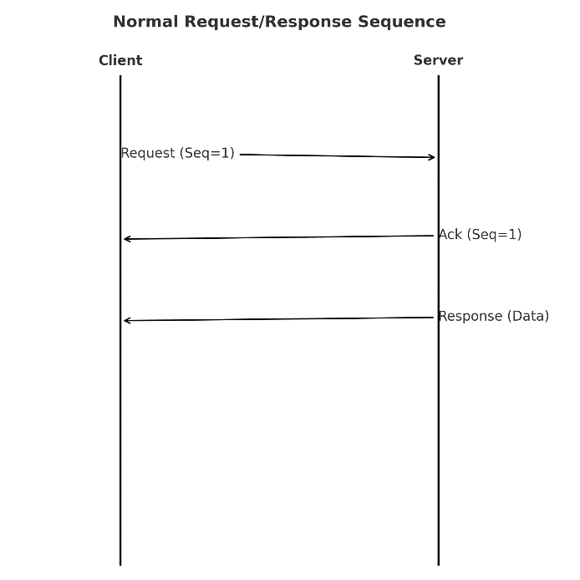

Error Flow
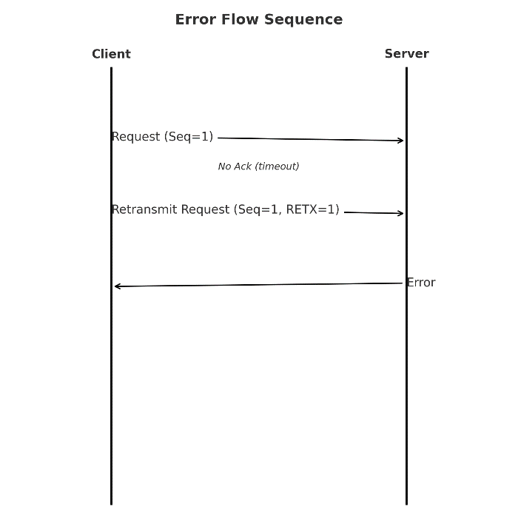

Figures 3 and 4: seq diagrams illustrating normal and error message flows

